# [Law & Order: SVU, Organized Crime hyped in new teaser](https://cartermatt.com/410913/law-order-svu-organized-crime-hyped-in-new-teaser/)

[Law & Order: SVU](https://cartermatt.com/tag/law-order-svu/) July 17, 2020

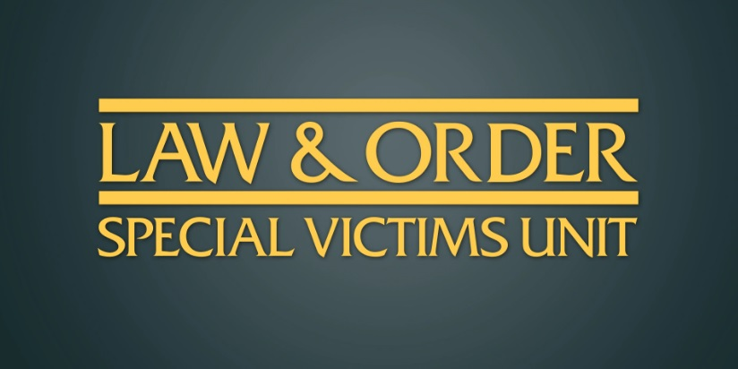There was a lot of NBC cross-promotion going on during the epic *30 Rock* reunion special tonight, but there was one moment that may prove to be especially exciting for long-term fans of [*Law & Order: SVU*](https://cartermatt.com/tag/law-order-svu/)*.* We saw one of the first official teases for the upcoming *Law & Order: Organized Crime* spin-off!

This is a show that we’ve been waiting to see for months now, given that it marks the return of Christopher Meloni as Stabler to the franchise. It obviously takes place many years removed from his departure from *SVU,* as a personal tragedy may lead to him getting back into the world of law enforcement. Nothing has filmed as of late on *Organized Crime* due to the global health crisis, so the tease was mostly a compilation of voice-overs and moments from the past.

While *SVU* and *Organized Crime* are technically two separate shows, there seems to be real effort in having them occasionally are a universe. There’s so much excitement from Meloni and Mariska Hargitay to revisit their characters around each other; with that, we have to imagine it will happen on occasion. These shows may be separate, but they can inform one another and build a stronger overall world.

Schedule-wise, NBC is going to be using *SVU* in order to build into *Organized Crime* on Thursday nights, and this is a move that should help both shows. First and foremost, *SVU* gets to move into an earlier timeslot and hopefully one with a stronger lead-in. From there, *Organized Crime* feels primed to keep the majority of viewers who watch the previous show. We’ll have to wait and see on the ratings, but we’re hopeful for now. Let’s also remain hopeful that things improve in this country and production on *Organized Crime* will start later this year.